**ASP.Net Training Assessment**

**Login Screen:**

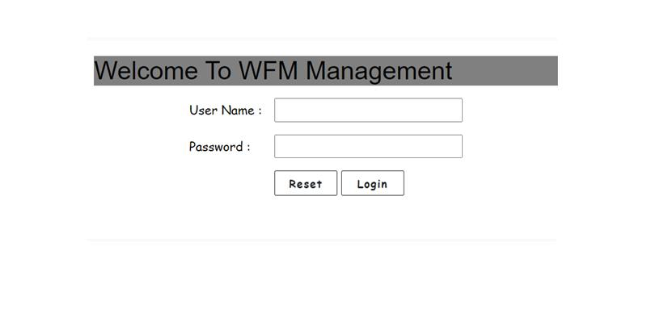

**1)Manager Screen:**

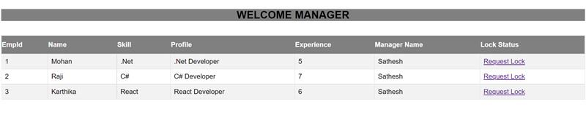

**2) Soft Lock Request**

**1)WFM_Manager:**



**2)Soft Lock Request:**

